

Aabi Zaraat.ai

## PROJECT SUPERVISOR

Ms. Sania Urooj

## PROJECT CO-SUPERVISOR

Dr. Muhammad Farrukh Shahid

## PROJECT TEAM

Syed Aun Ali Zaidi K20-0286

Muhammad Fahad K20-0441

Muhammad Mudabbir K20-0273

Submitted in partial fulfillment of the requirements for the degree of Bachelor of Science in Computer Science.

FAST SCHOOL OF COMPUTING

NATIONAL UNIVERSITY OF COMPUTER AND EMERGING SCIENCES KARACHI CAMPUS

Spring 2024

|  |  |
| --- | --- |
| Project Supervisor | Mr. Supervisor Name |
| Project Team | Syed Aun Ali Zaidi K20-0286  Muhammad Fahad K20-0441  Muhammad Mubabbir K20-0273 |
| Submission Date | May 16, 2024 |

## Ms. Sania Urooj

Supervisor

## Dr. Muhammad Farrukh Shahid

Co-Supervisor

## Dr. Atif Tahir

Head of Department

FAST SCHOOL OF COMPUTING

NATIONAL UNIVERSITY OF COMPUTER AND EMERGING SCIENCES KARACHI CAMPUS

# Acknowledgement

We are thankful to Allah and His blessings.

We would like to express our utmost gratitude to our supervisor, Dr. Muhammad Farrukh Shahid, for his enthusiasm, patience, insightful comments, helpful information, practical advice, and unceasing ideas that have helped us tremendously at all times, especially during research and development of this project. His immense knowledge, profound experience, and professional expertise in computer vision and AI-Driven systems has enabled us to complete this project successfully. Without his support and guidance, this project would not have been possible.

We are also thankful to our FYP jury and FYP committee for their guidance at each evaluation

# Abstract

In the domain of research and development, our research introduces a potential innovative solution that is tailored for business-to-business (B2B) users. Our research document focuses on the implementation of sustainable organic farming practices in Pakistan through the integration of aquaculture. The aim is to address the challenges faced by the agriculture sector in the country and explore potential solutions for enhancing soil health and optimizing fish farming practices. Utilizing cutting-edge technology, we have developed a system that leverages smartphone cameras to accurately identify and classify soil types and fish species that is locally found across Pakistan. In case of fish classification, our mobile app allows users with comprehensive insights into the identified fish’s properties (via the use of browser automation (selenium) and web scraping (beautiful soup)). Using LLM (Large Language Model - Mistral 7B), our work also provides detailed information on the recommended fish species, accompanied by precise ingredient proportions details. This amalgamation enhances protein levels within the specific soil, resulting in an optimal soil health. In the context of soil classification, the same procedure applies (like fish classification). The app also instructs user with precise blending instructions, specifying the optimal combination of fish species, other ingredients, and suitable soil types for achieving the best outcomes. Our methodology employs artificial intelligence, deep learning, and computer vision to facilitate a symbiotic relationship between agriculture and aquaculture, promoting economic growth. When it comes to sustainable agriculture in Pakistan, the challenge of enhancing soil fertility while maintaining ecological balance is paramount. Our research addresses this by proposing a method that synergizes soil and fish species classification to create a nutrient-rich fish fertilizer. This practice, rooted in traditional agriculture, is optimized through our system to utilize resources efficiently, leading to improved agricultural outcomes. We have developed an automated system powered by artificial intelligence that simplifies the creation of fish based organic fertilizer, tailored to the specific needs of Pakistani agriculture. The potential benefits of this research include promoting intelligent and sustainable agricultural practices (by moving away from continuous use of harmful chemical fertilizers), enhancing soil nutrient levels, and optimizing fish farming practices. By integrating modern technology with traditional practices, this research offers an economical and feasible solution for sustainable organic farming in Pakistan.

Index Terms—Artificial Intelligence, Deep Learning, Computer Vision, Agriculture, Aquaculture, Economical, Sustainable Solution, Environmentally Friendly.

Contents Page

Abstract…………………………………………………………………………………….. 4

Introduction…………………………………………………………………………...……. 7

Literature Review………………………………………………………………………….. 12

Methodology……………………………………………………………………………….. 24

Research Project Objectives……………………………………………………………….. 28

Research Design…………………………………………………………………………… 29

Results and Findings……………………………………………………………………….. 31

Future Research Dimensions………………………………………………………………. 36

Stakeholders………………………………………………………………………………... 37

Requirements………………………………………………………………………………. 38

Assumption and Dependencies…………………………………………………………….. 39

Use Cases…………………………………………………………………………………... 40

Functional Requirements…………………………………………………………………... 44

Non - Functional Requirements……………………………………………………………. 45

Sequence Diagram…………………………………………………………………………. 46

Software Architecture ……………………………………………………………………... 46

Implementation…………………………………………………………………………….. 47

Testing and Evaluation…………………………………………………………………….. 51

Conclusion…………………………………………………………………………………. 54

References…………………………………………………………………………………. 55

# List of Figures

1 Current Scenario Reference Picture 9

2 Contributions made in Aabi Zaraat.ai 11

3 Roadmap of Literature Review 12

4 Scenario for the proposed work 25

5 Halal (edible) Fishes 26

6 Haram (edible) Fishes 26

7 Alkaline Soil 27

8 Saline Soil 27

9 Mixture Soil 28

10 Training Validation Accuracy of CV Models 32-34

11 Confusion Matrix of CV Models 34-36

12 Use Case Diagram & Tables 41-44

13 Sequence Diagram 46

14 Software Architecture 47

15 Backend Implementation 47-50

16 Frontend Implementation 50-52

# Introduction

In recent years, Artificial Intelligence (AI) has improved significantly due to many developments and advancements in the field. Many mobile applications are being built in the domain of AI that are accessible through our trusty smart phones. The usability of AI is further extended by techniques such as Deep learning (DL) and Computer Vision (CV), which happens to be our domain of research-based development. Deep learning and computer vision are two cutting-edge fields of artificial intelligence that have found extensive applications in various real-life scenarios, transforming industries and enhancing our everyday experiences. These technologies have demonstrated remarkable capabilities in recognizing patterns, extracting meaningful information from visual data, and making intelligent decisions based on visual inputs. In this research, our focus will be on the intersection of modern available technological prowess and the vital sectors of agriculture and aquaculture in Pakistan by harnessing the extended techniques AI has to offer. The backbone of Pakistan’s economy is agriculture, and as time progresses, the agricultural system of Pakistan calls for an innovative solution that can bridge the gap between technology and farming. This need forms the backdrop for our research-based development.

The current agricultural landscape of Pakistan faces a critical challenge of enriching nutrient-depleted soil for sustainable and organic farming practices. Traditional farming methods, coupled with the depletion of essential nutrients in the soil, necessitate an innovative approach to revolutionize agriculture. In response to this, our research introduces a mobile application that leverages modern technologies—specifically, machine learning, computer vision, and artificial intelligence. Existing agricultural practices in Pakistan often rely on chemical fertilizers, leading to soil degradation and environmental concerns. Over-reliance on inorganic fertilizers has disrupted the natural balance of nutrients in the soil, leading to nutrient imbalances and reduced soil quality. Inorganic fertilizers have a higher potential for leaching compared to organic fertilizers, posing concerns about nitrate contamination in drinking water. They also contribute to the emission of nitrous oxide (N2O), a potent greenhouse gas and substantial carbon dioxide (CO2). This can result in habitat destruction, deforestation, and biodiversity loss. Cleaner and more sustainable production methods, such as utilizing renewable energy sources, are imperative to mitigate these environmental impacts.

The proposed mobile application addresses this issue by providing a user-friendly interface that allows farmers and agriculture enthusiasts to identify and classify diverse soil types and fish species through their smartphone cameras. This technology-driven solution builds upon previous research in the field of agriculture, aiming to bridge gaps and overcome limitations. Picture a mobile application that uses the power of smart phone’s camera to revolutionize two critical aspects of general digitally-driven organic farming systems: fish & soil classification and their assessment. An example can be the procedure of Fish hydrolysate [1], a nutrient-rich liquid or powder produced from fish waste and byproducts, serves as a valuable organic fertilizer and soil conditioner, enhancing plant growth and soil health. We aim to leverage its potential to improve agricultural activities on poor soil. The end developed product, based on this research, is specifically designed for business-to-business (B2B) users which will be a mobile application, opening up a plethora of possibilities in the agricultural landscape of Pakistan. When the app is being used for soil classification, it becomes a knowledgeable ally for farmers and soil inspectors. Along with identification of soil, the app offers great insight into each soil type’s unique properties. Moreover, the app also offers recommendation of the most compatible fish species for a given soil. The application also provides the user with precise instructions on the incorporation of extracted nutrient from fishes, a strategic move to boost soil protein levels and enhance overall soil health. Moving on to the next use case of our project, which is fish classification [2][3]. The dataset that will be used to train the model for fish classification will be collected locally (commonly found in the fish markets of Karachi), just like the soil dataset. The application will provide extensive information about the fish under scrutiny. The application will also guide the user on the ideal combination of fish species, additional ingredients, and compatible soil types to achieve optimal results. With this technologically innovative research-based development, we aim to practically create a farming companion. The solution, in the form of an application, will simplify the complexities of agriculture while automating the Nutrient Extraction procedure. With just a single tap on the screen, users can access a realm of agricultural insights, making their farming endeavors smarter, more efficient, and undoubtedly more accessible. The core of our research is to promote intelligent and sustainable agricultural practices. With our work, this goal is well within reach. In the Fig 01, we can observe how agriculture and aquaculture are interlinked with each other.

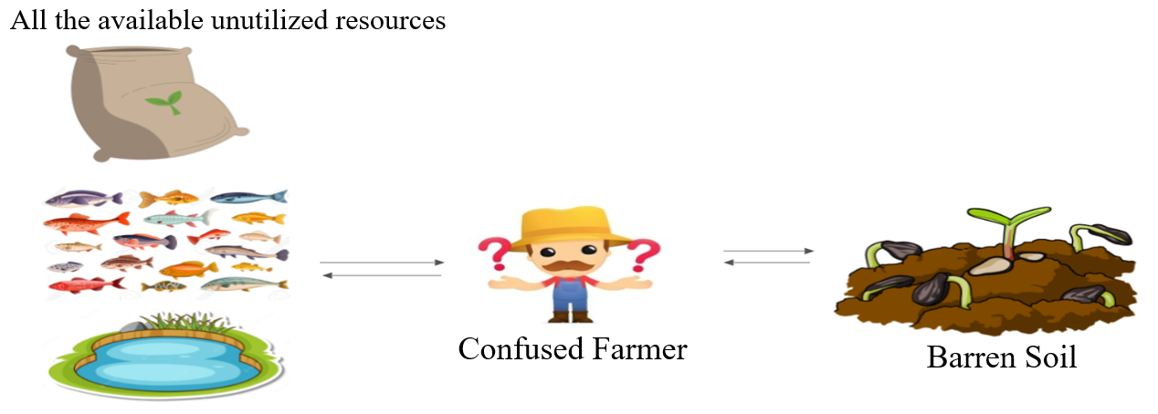

Figure 1: Current Scenario

Following are the contributions made by our research:

• Improved Food Safety:

– Enhanced fish classification ensures consumers can confidently identify halal and haram fish, promoting food safety.

• Sustainable Agriculture Practices:

– Recommendations for soil-fish compatibility contribute to sustainable farming practices, optimizing resource utilization.

• Efficient Resource Management:

– Accurate soil classification aids in efficient use of agricultural resources, reducing waste and promoting environmental sustainability.

• Informed Consumer Choices:

– Clear classification of fish helps consumers make informed choices aligned with their dietary preferences and religious beliefs.

• Supporting Agriculture Industry:

– Providing a reliable mapper supports farmers in optimizing their farming strategies, potentially improving crop yields.

• Empowering Local Farmers:

– The application’s recommendation system can empower local farmers with data-driven insights, potentially increasing agricultural productivity.

• Educational Outreach:

– Through detailed documentation and research, the project contributes to educational resources in the field of AI, agriculture, and food classification.

• Technology Accessibility:

– The mobile application ensures that technology driven solutions are accessible to a wider audience, promoting inclusivity.

• Data-Driven Decision Making:

– The project encourages data-driven decision-making in agriculture, fostering efficiency and sustainability.

• Promoting Ethical AI Use:

– By focusing on halal and haram classifications, the project highlights the ethical use of AI technology in alignment with cultural and religious values.

These contributions aim to positively impact society by promoting food safety, supporting sustainable practices, empowering local farmers, and providing valuable insights to consumers and the agriculture industry.

* 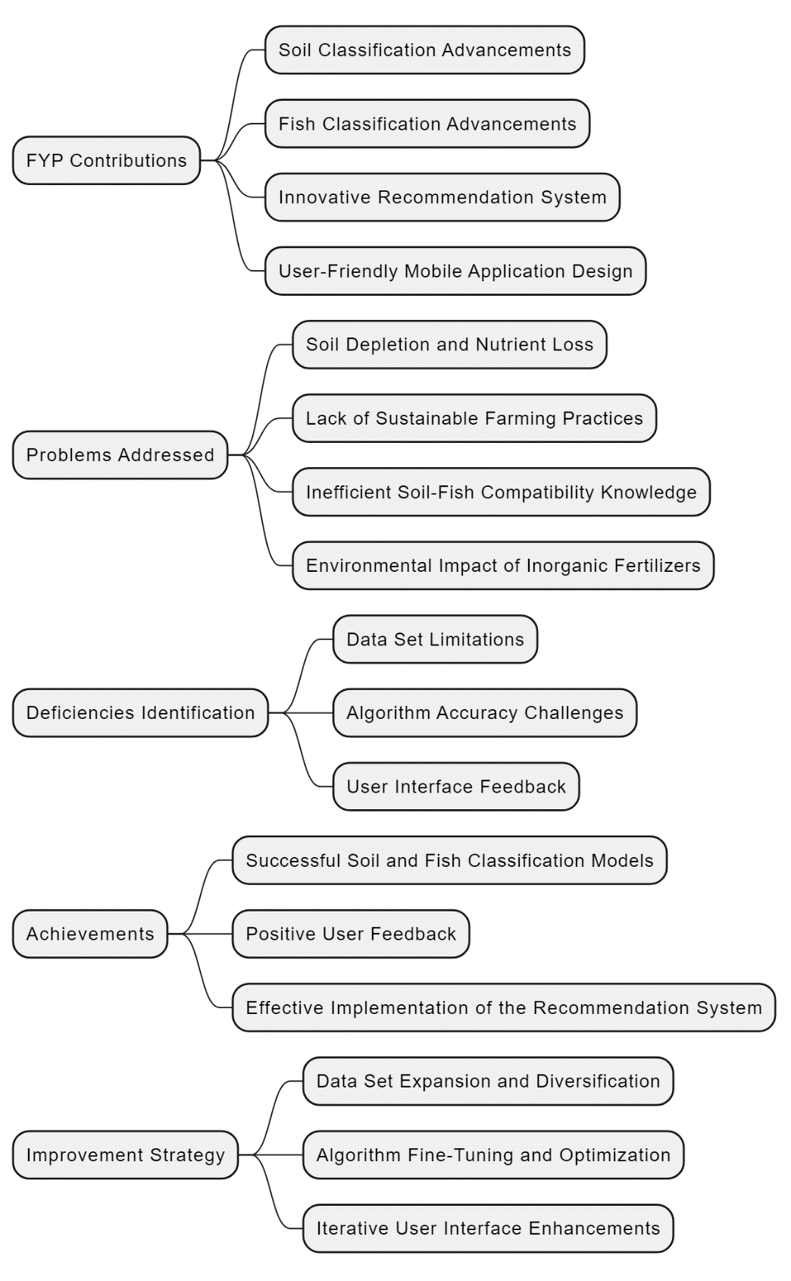Following diagram encapsulates the contributions made in our FYP Aabi Zaraat.ai. The visual representation highlights our achievements, addresses identified deficiencies, and provides a clear overview of the problems tackled:
* Following Roadmap diagram represents the workflow of the Literature Review section:

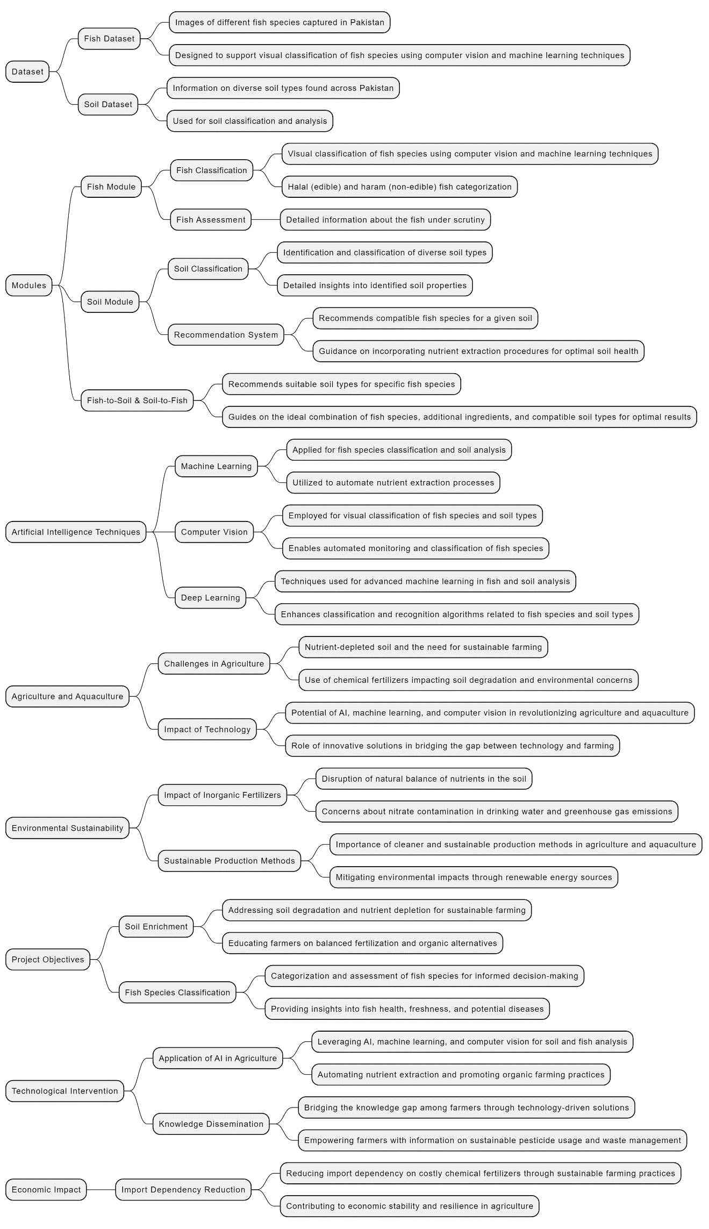

# Literature Review

In this section, we delve into the existing body of knowledge related to the agricultural challenges faced in Pakistan. Examining the current state of soil degradation, nutrient depletion, and unsustainable farming practices, we highlight the critical issues that necessitate innovative solutions. By providing context and insight into the prevailing problems, this literature review sets the stage for the significance of our research.

* **Agriculture and Pakistan:**

In this section, we review research on the impact of chemical fertilizers, traditional farming methods, and their contribution to soil degradation. Understanding the intricacies of soil management practices is crucial for formulating effective strategies, and this review aims to synthesize existing knowledge in this domain. The economic significance of land degradation in Pakistan is highlighted in the document, emphasizing the importance of maintaining a growth rate of more than five percent in the agriculture sector for rapid national income growth, macroeconomic stability, employment opportunities, and poverty reduction. The Medium-Term Development Framework (MTDF) 2005-10 emphasizes the crucial role of the agriculture sector in the national economy and envisions an increase in agricultural growth to achieve these economic objectives. The document further discusses how the degradation of natural resources, including land, contributes to the vulnerability of farmers, particularly in dryland areas. It points out that inadequate natural resource management has led to low agricultural productivity, poor living standards, and limited opportunities for economic advancement. Additionally, it emphasizes that sustainable and efficient management of natural resources is essential for improving productivity and reducing poverty in rural areas. The impact of land degradation on agricultural productivity, rural livelihoods, and national economic growth is underscored, signaling the need for effective measures to address this issue. Furthermore, the document highlights the importance of incorporating the perspectives and participation of local farmers and communities in the planning and implementation of policies and interventions to address land degradation. This inclusive approach is seen as essential for creating awareness, promoting sustainable land management practices, and empowering those most affected by land degradation to participate in decision-making processes. [4] Based on the given ICARDA Survey [4], the commonly found soil types in Pakistan are: 1. Clayey 2. Loamy 3. Sandy 4. Calcareous 5. Silt-loam 6. Moderately Calcareous 7. Silty clay loam 8. acidic (above 2100 altitude) 9. Calcareous at lower altitude According to the survey [4], common reasons found for the land degradation in Pakistan are: 1. Water erosion: The impact of erosion caused by water, particularly in areas with intense summer rainfalls and melting snow, affecting approximately 11 million hectares of land. 2. Wind erosion: It is mentioned that overgrazing, deforestation, and water erosion have led to significant land degradation, affecting around 24 million hectares, particularly in dryland and upland areas such as Baluchistan, NWFP, and parts of Punjab. 3. Depletion of soil fertility: The removal of topsoil has resulted in declining soil fertility, impacting the production of forage, fodder, fuelwood, timber, and grains. 4. Deforestation: Its impact has been discussed on river basins in Sindh and Punjab, leading to widespread land degradation affecting approximately 11 million hectares. 5. Livestock Grazing Pressure: Overgrazing is identified as a significant contributor to land degradation, particularly in areas affected by deforestation, water erosion, and wind erosion. 6. Loss of Biodiversity: It is noted that the increasing human and livestock population has put enormous pressure on natural vegetation, leading to a decrease in biodiversity in various agro-ecological regions. 7. Water logging and Salinity: Poor irrigation practices have led to water logging and salinity, affecting approximately 14 million hectares of land. 8. Drought and Flooding: The recurring challenge of drought in arid and semi-arid regions of Pakistan has caused adverse effects on agriculture and human activity, as well as the significant impact of flooding during monsoon seasons. 9. Socio-economic constraints: The survey highlights the economic impacts of land degradation policies, coping strategies, and technological interventions, emphasizing the importance of addressing socio-economic factors in managing land degradation and sustainable agricultural practices. 10.Soil Pans: The survey mentions the formation of a dense "plough pan" due to continuous use of traditional ploughs, hindering water penetration and plant root growth, particularly pronounced in silty soils. 11.Soil Nutrient Degradation: The survey pointed out the deficiency of nitrogen, phosphorus, potassium, Sulphur, and other nutrients in cultivated soils, particularly in irrigated sandy and loamy soils, highlighting the causes of nutrient loss such as leaching, continuous cultivation, and a hot and arid climate. The following text by “The Nation” suggests that the lack of knowledge is endangering our Food security, it states: “The recent report by the Sindh Food Authority (SFA) exposes the alarming persistence of cultivating vegetables with sewage water on the outskirts of Karachi, despite court directives. This poses severe health risks, with experts warning of diseases like hepatitis and cancer due to the absorption of sewage chemicals by crops. The lack of enforcement and coordination among authorities is a significant factor in this ongoing issue. The SFA's identification of problematic areas is commendable, but stringent regulations, penalties, and collaboration with experts are urgently needed. Establishing food laboratories in universities, as seen in the accord with the University of Karachi, is a wise step to ensure food quality. Consumer caution, support for local farmers following proper practices, and awareness about risks are essential. Government action, strengthened regulatory frameworks, and collaboration with experts are crucial, alongside individual responsibility in making informed and sustainable choices.” [7] IIPS has listed several key benefits for Pakistan if sustainable agriculture is practiced, some of them are [8]: 1. Improved Food Security: Sustainable agriculture practices lead to higher and more stable crop yields over time, ensuring a consistent food supply for Pakistan's growing population. 2. Economic Growth: By adopting sustainable farming techniques, farmers can reduce input costs, increase their income, and access premium markets for organic and sustainably produced goods. 3. Environmental Conservation: Sustainable agriculture helps protect ecosystems, reduce greenhouse gas emissions, and conserve water resources, contributing to long-term environmental sustainability. 4. Resilience to Climate Change: Diversified cropping systems and climate-smart practices make agriculture more resilient to the effects of climate change, reducing vulnerability to extreme weather events. 5. Enhanced Livelihoods: Sustainable agriculture practices can improve the wellbeing of rural communities by creating employment opportunities and improving access to nutritious food. These were the background that necessitate innovative solutions, and we are providing exactly that with our work Aabi Zaraat.ai.

* **Soil Health and Agricultural Practices:**

This subsection explores studies and findings related to soil health and conventional agricultural practices in Pakistan. We review research on the impact of chemical fertilizers, traditional farming methods, and their contribution to soil degradation. Understanding the intricacies of soil management practices is crucial for formulating effective strategies, and this review aims to synthesize existing knowledge in this domain. Soil is an essential component for sustaining life. It provides crucial ecological services. Managing soil health is vital for biodiversity and sustainable agriculture. The physicochemical and biological properties of soil regulate its health. While modern agriculture heavily relies on fertilizers, their use poses threats to the environment. Chemical fertilizers enhance crop productivity and soil fertility but have serious detrimental effects. Continuous usage leads to a decline in soil organic matter, hardening of the soil, pollution, and reduced nutrient content, posing environmental hazards. The exclusive use of chemical fertilizers weakens microbial activity, alters soil pH, increases pests, and contributes to greenhouse gas emissions. This persistent use influences soil biodiversity and overall well-being, highlighting the need for sustainable agricultural practices. [9] As per study conducted by Pakissan regarding “Fertilizer And Environmental Pollution In Pakistan”, the potential consequences of over-application of fertilizers in Pakistan include various harmful negative effects. These consequences are: 1. Environmental Pollution: Over-application of fertilizers can lead to environmental pollution through the leaching of nitrogen into groundwater, rivers, lakes, and coastal waters. This pollution can also result in the eutrophication of water sources, causing algal blooms, heavy growths of aquatic plants, and deoxygenation, which can harm aquatic organisms. 2. Accumulation of Heavy Metals: Phosphorus fertilizers can lead to the accumulation of heavy metals such as cadmium in agricultural products. Over time, the continuous use of phosphatic fertilizers can result in the accumulation of cadmium in crops, posing a threat to human health if consumed. 3. Gaseous Loss and Air Pollution: Excessive use of nitrogenous fertilizers can result in gaseous loss of nitrogen into the atmosphere, leading to the release of carbon dioxide, ammonia, and oxides of nitrogen. These pollutants can affect human health, contribute to respiratory diseases, and potentially harm the ozone layer. 4. Human Health Concerns: Cadmium accumulation in agricultural products due to the use of phosphorus fertilizers can result in human health problems such as kidney damage, bone deformities, and cardiovascular issues. 5. Agricultural Sustainability: Over-application of fertilizers can disrupt the ecological balance, upset the existing soil fertility, and lead to unstable yield levels. This can impact long-term agricultural sustainability and the quality of food and fodder. It is important to consider these potential consequences when discussing traditional farming methods in Pakistan and the shift towards chemical fertilizer use. Efforts to raise awareness about balanced fertilization, soil testing, and the proper use of fertilizers can help mitigate these harmful effects and promote sustainable agricultural practices. 6. Cadmium Accumulation: The use of phosphate fertilizers containing cadmium can result in the accumulation of cadmium in crops. This poses a potential health risk, as high levels of cadmium consumption from contaminated crops can lead to human health problems. The document suggests the importance of soil testing before the application of fertilizers to determine specific crop nutrient needs, as blanket fertilizer recommendations may not be suitable for all crops or soil types. It emphasizes the need for local research to understand soil and crop conditions, balanced fertilization, and the use of organic alternatives such as animal manure and fish compost. The document also stresses the importance of educating and engaging extension workers to provide farmers with information, demonstrations, and guidance on proper fertilizer use and other agricultural practices. Additionally, it highlights the need for ensuring the availability of appropriate fertilizers based on soil types and crop demands, at the right time. These suggestions are aimed at promoting sustainable and efficient fertilizer use to mitigate the negative environmental and health effects associated with over-application. [10] Aabi Zaraat makes sure the user understands his/her owned soil in more depth and make informed decision about it. With ease of access to knowledge, farmers will be provided with proper guidance on how to make use of local resources for sustainable farming. Our app understands these intricacies of soil management practices and performs the crucial task of formulating effective strategies.

* **Technological Interventions in Agriculture:**

Here, we examine literature on the integration of technology, particularly machine learning, computer vision, and artificial intelligence, in addressing agricultural challenges. By analyzing previous research in similar domains, we build a foundation for the application of modern technologies in soil analysis, nutrient extraction, and sustainable farming practices. Some of the applications of deep learning in aquaculture include fish classification, fish counting, fish behavior monitoring, fish fillets defect detection, shrimp disease research, shrimp freshness detection, pearl classification, scallop counting, coral species classification, activity monitoring of cold water coral polyps, jellyfish detection, aquatic macroinvertebrates classification, phytoplankton classification, trend prediction of red tide biomass, dissolved oxygen content prediction, chlorophyll a content prediction, temperature prediction, marine floating raft aquaculture monitoring, obstacle avoidance in underwater environments, and virtual fish grasp. Deep learning is utilized in aquaculture for fish classification and fish behavior monitoring in various ways. For fish classification, convolutional neural networks (CNN) are commonly used to automatically extract features from fish images, enabling accurate classification of different fish species with high accuracy. This is achieved by training the CNN model on large datasets of fish images, allowing it to learn and differentiate between various visual characteristics of different fish species. Additionally, deep learning can also be combined with other technologies such as virtual reality and robotics to further enhance the classification and detection of fish in aquaculture environments. In terms of fish behavior monitoring, recurrent neural networks (RNN) are often employed to analyze video clips capturing different fish behaviors. RNN models are capable of learning and recognizing patterns in temporal data, making them suitable for detecting and classifying different fish behaviors based on video footage. By training RNN models on labeled video clips of normal and unusual fish behaviors, it becomes possible to achieve high accuracy in detecting, localizing, and recognizing specific fish behaviors. Additionally, the use of multimodal deep learning techniques allows for the integration of sensor data (such as motion sensors) with video data to provide a more comprehensive analysis of fish behavior in aquaculture environments. Overall, deep learning techniques, particularly CNN for fish classification and RNN for fish behavior monitoring, have demonstrated promising capabilities in enhancing the efficiency and accuracy of aquaculture operations. [11] Based on the document FISH-PAK, the technological interventions, particularly in the fields of machine learning, computer vision, and artificial intelligence, have been employed in the agriculture of Pakistan through the development of the Fish-Pak dataset. This dataset consists of images of different fish species captured in Pakistan, and it is designed to support visual classification of fish species using computer vision and machine learning techniques. The dataset serves as a valuable resource for researchers and practitioners in the field of fisheries and aquaculture, enabling the automated monitoring and classification of fish species, which can be beneficial in fisheries research and the study of fish diversity. Additionally, the use of convolutional neural networks (CNN) is highlighted as one of the most widely used architectures for image classification based on visual features, demonstrating the application of advanced machine learning techniques in this domain. The development of the Fish-Pak dataset contributes to the advancement of technological interventions in the agriculture sector of Pakistan in several ways: 1. Visual Classification: The dataset enables the visual classification of fish species using computer vision and machine learning techniques. This can aid in the identification and categorization of different fish species, which is beneficial for fisheries research and fish diversity studies. 2. Algorithm Testing: The dataset provides a valuable resource for testing and evaluating classification and recognition algorithms related to fish species. Researchers and practitioners can compare various factors of classifiers, such as learning rate and momentum, to assess their impact on overall performance. 3. Convolutional Neural Networks: The document highlights the use of Convolutional Neural Network (CNN), one of the most widely used architectures for image classification based on visual features. By employing advanced machine learning techniques like CNN, the dataset contributes to the application of cutting-edge technology in the agriculture sector of Pakistan. 4. Supporting Research: The availability of a comprehensive dataset like Fish-Pak supports research and development in the fields of fisheries and aquaculture. It provides a foundation for further advancements in technology-driven approaches to fish species classification and monitoring. Overall, the development of the Fish-Pak dataset represents a significant technological intervention in the agriculture sector of Pakistan by leveraging machine learning, computer vision, and artificial intelligence to advance the study and management of fish species, thereby benefiting the fisheries and aquaculture industries. [12] Our work will be an improvement over this work done by the Pakistani researchers on Pakistani field. AI is increasingly integral to fisheries management and seafood processing, with applications including image recognition, data analysis, and tracking fishing activities. Companies like This Fish are using AI to automate data collection and improve seafood processing, while Global Fishing Watch and The Nature Conservancy are leveraging AI to monitor fishing activities and prevent overfishing. Aquaculture companies are also harnessing AI to enhance operations. The use of AI in fisheries management and electronic monitoring has become inevitable, with companies like Thai Union making significant commitments to on-water monitoring. AI is also being used to analyze color and defects in seafood processing, providing valuable insights for quality control measures. Some examples of aquaculture companies using AI to enhance their operations include Umitron and Aquaconnect. Both companies are leveraging the power of artificial intelligence to improve various aspects of their aquaculture operations, such as monitoring, feed management, and environmental control. This use of AI is helping aquaculture companies optimize their processes and ultimately improve the efficiency and sustainability of their operations. [13] The people in Pakistan have responded positively to the advancements in fish farming and the expansion of the aquaculture industry. There has been a notable embrace of innovative techniques and technologies to increase productivity, improve product quality, and diversify species of fishes. In addition, the improvement in terms of technology for aquaculture industry has empowered local communities, and enhanced food security. The government has actively promoted the sector through various policies and initiatives, and there is growing recognition of the importance of social and economic aspects in aquaculture development, including the inclusion of local communities as active participants in the industry. These responses indicate a favorable and supportive environment for the growth and sustainability of the aquaculture-agriculture industry in Pakistan. [14]

* **Sustainable Agriculture and Environmental Impact:**

Reviewing literature on sustainable agricultural practices and their environmental implications, this subsection provides insights into the global shift towards eco-friendly farming. By understanding the broader context of sustainable agriculture, we position our project within the larger framework of environmentally conscious practices and their potential impact on the agricultural landscape. Aquaculture in Pakistan presents a compelling opportunity to revitalize the fisheries sector and contribute to economic development and food security. With a vast coastline and abundant natural water resources, the country has the potential to significantly enhance its aquaculture industry. However, the current aquaculture practices are limited, particularly in the marine and coastal areas, with the majority of production coming from capture fisheries. In order to address the challenges and leverage the opportunities in Pakistan's aquaculture sector, there is a critical need to shift towards sustainable agricultural practices. This shift entails comprehensive research and development approaches that align with the principles of sustainability, environmental conservation, and the well-being of local farmers. The performance of the fisheries sector is not only crucial for economic development but also from the perspective of nutrition security and the overall macroeconomic stability of the country. To ensure the long-term sustainability of aquaculture in Pakistan, it is essential to prioritize the efficient and sustainable management of aquatic resources. This involves promoting environmentally friendly farming practices, optimizing resource utilization, and mitigating the adverse environmental impact of conventional methods. Furthermore, there is a need to support community-based aquaculture projects in a sustainable manner, ensuring that they contribute to both local livelihoods and environmental conservation efforts. The literature focuses on sustainable agriculture and aquaculture in Pakistan and emphasizes on the importance of embracing environmentally conscious practices to address the challenges faced by the fisheries sector. By positioning our project within this larger framework of sustainable agricultural practices, we aim to contribute to the revitalization of aquaculture in Pakistan while mitigating its environmental impact and promoting the well-being of local communities. [15] Research by BANGABANDHU SHEIKH MUJIBUR RAHMAN MARITIME UNIVERSITY in this field states the potential role of aquaculture in addressing the imbalance in food production and water use in irrigated farming systems in Punjab, Pakistan. It highlights the need for research to develop distinct and sustainable approaches to integrated animal protein production from aquatic resources. The integration of various fish production approaches into existing land and water use practices is deemed feasible, with a focus on small and medium-scale carp production in ponds using groundwater. Integrated aquaculture is seen as a way to address food security needs and could contribute to various components of water distribution and irrigated farming systems in the region. The document emphasizes the importance of promoting recycling of agricultural residues, reducing pesticide use, and making better use of scarce water resources through integrated aquaculture production. [16] The document “Fish and fish waste-based fertilizers in organic farming” discusses the potential for utilizing fish waste (FW) to produce fertilizers applicable for organic farming, particularly in horticultural and crop plants. It emphasizes the recycling of nutrients from captured fish to promote a circular economy and sustainable agricultural practices. The nutritional composition of FW is evaluated to determine its potential as a source of plant nutrients, including nitrogen and phosphorus. Various processing methods for FW are explored, such as producing fish emulsion, fish hydrolysate, fish compost, and anaerobic digestion. The document also examines the availability of commercially available fish-based fertilizers and the establishment of a fish waste-based fertilizer industry in Europe. For improvement in production for horticultural plants in Pakistan, similar approaches can be adopted to utilize fish waste to develop organic fertilizers tailored to the nutrient needs of horticultural crops in the region, thus promoting sustainable and environmentally friendly agricultural practices which we intent to do in our Pakistan based project [17]. Another fertilization of soil technique that we can use in our project is AnchoisFert, a fertilizer derived from milled anchovy leftovers. The experiment involved using pots with specific soil conditions and amendments, and the effects of the fertilizers on the soil properties were evaluated. The analysis included measurements of conductivity, pH, organic carbon, total nitrogen, microbial biomass, enzyme activities, and water-soluble phenols. The authors also conducted radical-scavenging activity and oxygen radical absorbance capacity assays to assess the antioxidant properties of the soil extracts. The statistical analysis showed significant differences in the effects of the fertilizers on the measured parameters [18]. Regarding its feasibility in Pakistan, the production of fertilizers from fish waste could have significant potential, given the country's significant fish processing industry and associated waste. The use of a mobile application to provide farmers with step-by-step guidance on the production and application of these fish waste-derived fertilizers could further enhance its feasibility and scope in Pakistan. Our mobile application could offer information on the extraction process, guidelines on producing the fertilizer, and instructions on its optimal application for different crops and soil conditions, thereby aiding in the widespread adoption of this eco-friendly and sustainable fertilizer solution. There is a literature that explores the valorization of fish waste compost as a fertilizer for agricultural use. It discusses the handling of waste and its management, focusing on the composting of food waste and the potential for producing environmentally safe materials from bio-waste. It emphasizes the suitability of fish waste for composting due to its high nutrient content and mentions the commercial availability of fishmeal-based fertilizers authorized for use in organic agriculture. The literature highlights the growing research interest in sustainable management of food waste and the various techniques for processing waste into value-added products such as compost, biogas, animal feed, and chemicals. It is highly feasible for Pakistan environment [19].

* **Knowledge Deficit in Agriculture:**

This section focuses on literature that highlights the knowledge deficit among farmers and the impact it has on decision-making. Understanding the gaps in awareness and education is crucial for the successful implementation of our project. We explore studies that discuss the challenges of disseminating agricultural knowledge and propose methods to bridge this gap. The lack of awareness and training among farmers on sustainable pesticide usage and waste management is a significant concern. Many farmers are not aware of alternative pest control methods and rely solely on chemical pesticides as they believe it to be the only solution to control insects and pests. The study suggests that limited knowledge on alternative pest management approaches leads to the extensive use of pesticides, contributing to negative effects on human health and the environment. The findings also highlight that a large number of farmers become intoxicated each year due to the improper use of pesticides in cotton-growing areas of Pakistan. This is often attributed to low levels of knowledge about the harmful effects of pesticide exposure, leading to farmers and farm-workers rarely adopting precautionary measures while applying pesticides. In addressing these issues, the study underscores the importance of developing extension, educational, and capacity building programs for farmers on reducing the use of pesticides. These programs are vital for raising awareness about alternative pest control methods and changing farmers' behavior towards chemicals. It is suggested that through meaningful training programs, farmers can be empowered to adopt sustainable and environmentally sound production practices, which can lead to reduced reliance on chemical pesticides. Overall, the study highlights the need for comprehensive and well-planned programs to promote the benefits of alternative pest control methods, reduce the extensive use of pesticides, and improve the sustainable usage of pesticides to protect crops, human health, and the environment [20][21]. Aabi Zaraat ensures that people/farmers of Pakistan have access to such knowledge, so that they can implement modern day techniques and alternative sustainable solution on their farms that is organic farming. A study conducted in 2017 examined farmers' perceptions about climate change and environmental issues in Pakistan by utilizing indigenous knowledge. The findings revealed climate change as the most significant environmental problem, with farmers relying on scientists and the media for climate information. Farmers expressed the highest responsibility for addressing climate change but lacked trust in government and industry. The study highlighted constraints to adaptation, such as lack of funds, high cost of inputs, and limited knowledge. The integration of indigenous knowledge and locally relevant adaptation strategies is proposed to address these challenges and effectively inform policy-making [22]. The lack of knowledge among farmers regarding climate change can contribute to several negative consequences. Farmers may be less aware of changing weather patterns, shifting growing seasons, and new pest and disease pressures, which can lead to crop failure and reduced agricultural productivity. Additionally, farmers may not be aware of efficient and sustainable agricultural practices that can help mitigate the effects of climate change, leading to increased resource depletion, soil degradation, and greenhouse gas emissions. Technology and the spread of knowledge can play a crucial role in addressing this issue. Access to climate-smart agricultural practices, and tailored information on best farming practices can empower farmers to adapt to and mitigate the impacts of climate change. By harnessing technology and spreading knowledge, farmers can better prepare for and adapt to the challenges posed by climate change, ultimately leading to more resilient and sustainable agricultural systems [23]. The lack of knowledge among farmers contributes to climate change by leading to unsustainable agricultural practices that contribute to environmental degradation. Farmers may not be aware of climate-smart agriculture (CSA) practices, which can help mitigate the impact of climate change on agricultural productivity and reduce greenhouse gas emissions. This lack of knowledge can also result in overuse of chemical inputs, improper soil and water management, and inadequate adoption of climate-resilient crop varieties. The consequences of this lack of knowledge include decreased agricultural productivity, increased vulnerability to climate-related risks such as droughts and floods, and environmental degradation. Additionally, it can lead to soil erosion, reduced water quality, and loss of biodiversity, further exacerbating the effects of climate change. Technology and the spread of knowledge can help address this issue by providing farmers with access to information and tools that promote sustainable and climate-smart agricultural practices. For example, auto monitoring and precision farming technologies can help farmers monitor crop health, optimize input use, and adapt to changing weather patterns. Furthermore, targeted communication efforts and training programs can help raise awareness and knowledge among farmers about CSA practices, enabling them to adopt more sustainable and climate-resilient farming methods. By promoting the adoption of modern technology and providing the necessary knowledge, farmers can improve their productivity and profitability while mitigating the impact of climate change on agriculture [24].

# Methodology

# In this research, our focus is on efficiently classifying various types of fishes and soil, determining their optimal compatibility for the purpose of creating fish fertilizer in Pakistan’s agricultural sector. Currently, the existing procedure for this practice is inefficient, making suboptimal use of available resources. Our objective is to leverage a mobile application to enhance resource utilization, ultimately leading to significantly improved outcomes.

# Key to the success of our project is the utilization of locally sourced datasets collected from Karachi. These datasets form the backbone of our classification system, ensuring that the application is fine tuned to the specific soil and fish varieties prevalent in our region. Our approach encompasses both soil and fish, essential components in the fish’s nutrient extraction process. We propose an innovative method to automate the classification procedure using AI integrated into our mobile application. Figure 02 provides a visual representation of the envisioned workflow for our work. Users submit images of fish or soil to the system, which are then processed by our application. The processed files containing all relevant details are returned to the users, streamlining the classification process and making it more accessible. To enhance the accuracy of feature extraction from our image dataset, we adopt transfer learning with the ResNet V0 model. The dataset is divided into 70% for training, and the last 5 layers are fine-tuned (with potential changes during experimentation). This methodology aims to achieve an accuracy exceeding 94%, ensuring comprehensive retrieval of pertinent information about the object in the image from the database. Figure 02 visualizes the fundamental workflow, illustrating how different components of the system interact seamlessly. Through these advancements, our approach has the potential to revolutionize the classification process, making it more efficient and accurate for sustainable organic farming practices, and contributing significantly to the agricultural landscape in Pakistan. We will be using deep learning for classification. Our methodology involves the experimental setup, deep learning model, and evaluation criteria for system performance.

Figure 2: Considered scenario for the proposed work

# **A.** **Data Collection:**

# Various sites, such as interior Sindh, Fish Harbour Road (FHR) and Karimabad Aquariums, in Karachi were visited to collect an image dataset for fish and soil classification. The data collection adhered to standardized methods and protocols for accuracy and consistency.

# 1) Halal and Haram Fishes

# Our team conducted extensive field visits to various Karachi-based markets (such as Fish Harbour Road and Karimabad Aquariums) to collect a comprehensive dataset of halal and haram fishes. During these visits, we engaged with local fish vendors, discussed with them about the innovative use of fish for organic farming practices. We then captured high-resolution images of the available fish varieties, ensuring a diverse and representative dataset. This dataset serves as a foundation for our application’s fish classification system.

Figure 4: Haram (non-edible) Fishes

Figure 3: Halal (edible) Fishes

# Soil Types

# To gather information on soil types prevalent in different agricultural practices, we visited interior Sindh. These visits involved hands-on exploration of traditional farming practices, providing valuable insights into soil characteristics. Through on-site photography, we documented various soil types, considering factors such as texture, color, and composition. This dataset forms a crucial component of our application’s intelligent soil analysis and classification capabilities.

# 

Fig. 5. Sample Dataset - Alkaline Soil

Fig. 6. Sample Dataset - Saline Soil

# 

Fig. 7. Sample Dataset - Mixture Soil

# **Feature Extraction:**

# To gather information on soil types prevalent in different agricultural practices, we visited interior Sindh. These visits involved hands-on exploration of traditional farming practices, providing valuable insights into soil characteristics. Through on-site photography, we documented various soil types, considering factors such as texture, color, and composition. This dataset forms a crucial component of our application’s intelligent soil analysis and classification capabilities.

# **Deep Learning Model:**

# Different models are integrated for each respective stage to determine their effectiveness. The shortlisted algorithms include ResNet V0, EfficientNet and its variants. Model configuration is based on their performance during the respective stage, avoiding immediate determinations before testing.

# **Evaluation:**

# Test data with abnormalities is applied to the trained model, and performance is assessed by plotting confusion matrices and other accuracy detection forms. Abnormality graphs are plotted to identify anomalies in the classification. This integrated methodology ensures a systematic and comprehensive approach to the classification problem, aligning with the research objectives and contributing to the overall success of this research.

# Research Project Objectives

The main deliverable of this research project was to build, automate, and ease the procedure of creation of fish fertilizer for enhancing the nutrient level of soil. The main objectives were as follows:

1. **Data Collection:**

• Gathered extensive datasets of soil samples and fish species from the local Karachi market.

• These datasets served as the foundation for training and testing the deep learning algorithms used in the classification processes.

1. **Soil Classification:**

• Developed a robust soil classification system that utilizes the mobile app’s camera.

• Accurately identifies and classifies various soil types commonly found in Pakistan.

• Provides detailed information about each soil type, including its properties, composition, and suitability for specific agricultural purposes.

• Informs the user about the most compatible fish (required for protein enrichment) for that particular soil.

1. **Fish Classification:**

• Implemented a comprehensive fish classification module within the mobile app.

• Allows users to capture images of locally found fish species.

• Classifies fish with high accuracy, providing extensive details about each fish via the use of Selenium and Beautiful Soup.

• Informs the user about the most compatible soil (for the creation of fish fertilizer) for that particular fish and vice versa.

1. **Algorithm Development:**

• Utilized deep learning algorithms, such as ResNet V0, Efficient B0, MobileNet, InceptionV3, VGG19 & many more for both soil and fish classification.

• Fine-tuned the algorithms to achieve a classification accuracy of nearly 95%.

• Created a mapper model for fish-to-soil mapping and vice versa.

• Created a web scrapper for displaying extensive details about fishes.

1. **Web Application:**

• Designed an intuitive and user-friendly interface for the web app.

• Ensured ease of use for business-to-business (B2B) users.

• Provided a friendly experience for capturing images and receiving classification results.

1. **Recommendation System:**

• Implemented a LLM based recommendation system within the app.

• Suggest the most compatible fish species for a given soil type and vice versa along with recommended fish nutrient extraction procedure, ingredients required for that particular process and physical equipment that will be used in throughout the process.

# Research Design

Our research design comprised of several distinct phases, each contributing to the development of our AI-driven mobile application that leverages cutting-edge technologies, including advanced AI algorithms, machine learning, and computer vision. The system will utilize real-time data acquisitions from smartphones’ hardware and use their computing capabilities to facilitate storage, analysis, and more. This research-based project consisted of the following phases:

1. *Comprehensive Literature Review*

In this phase, we conducted an extensive literature survey to identify state-of-the-art techniques in the field, focusing on various deep learning methodologies within the domain of artificial intelligence. Our exploration included research materials that delve into the amalgamation of practices in both agriculture and aquaculture.

1. *Data Collection*

During this stage, we visited the local fish market in Karachi to capture images and build a dataset. The same procedure extended to the collection of datasets for soil, ensuring a locally sourced dataset that accurately represents conditions in Pakistan.

1. *Data pre-processing (Feature Extraction)*

Following dataset collection, we engaged in extracting features (patterns) from fish and soil images. This entailed cleaning, organizing, and preparing the data for analysis. For soil data, we focused on extracting relevant features related to composition and texture, while in the case of fish data, emphasis was on attributes such as size, color, and shape.

1. *Deep Learning Model*

In this crucial phase, we leveraged deep learning techniques, including transfer learning and fine-tuning strategies. Specifically, we use the ResNet V0 model for soil and fish classification. Training involves preparing datasets to achieve high accuracy in classifying soil types and fish species, with a target surpassing 94% accuracy.

1. *Web Development*

Following model training, we transitioned to web app development. Our web app prioritizes user-friendliness and compatibility with business-to-business (B2B) usage. The ResNet V0 model operates at the back-end, managing the classification procedure seamlessly

1. *Integration and Testing*

To ensure the web application’s functionality, rigorous testing is conducted using real-time local data from Karachi. This testing phase provides valuable feedback for further refinement.

1. *Evaluation*

This phase involves the evaluation of the ResNet V0 model using confusion matrices and other validation techniques. Abnormal curves are plotted to analyze the model’s performance, addressing any shortcomings and implementing optimization strategies accordingly.

1. *Writing-up and Documentation*

Throughout this research, comprehensive documentation was maintained, encompassing methodologies, data, code, and results. This documentation serves as the foundation for journal articles, conference papers, and project reports, facilitating the sharing of findings and contributions with the scientific community.

# Results And Findings

# Training and Validation Accuracy:

# Training and validation accuracy with respect to epochs for the current fish species on the proposed model is plotted in Fig. 4-8. Results of applying the model on the dataset and plotting a traditional confusion matrix of the predictions (Fig. 9).

# 

Figure 11: Training Validation Accuracy Per Epoch-ResNetV0

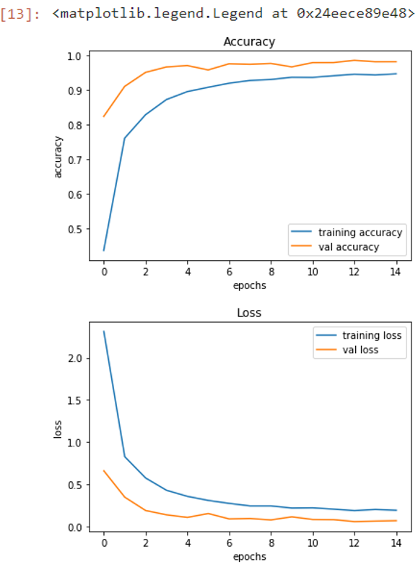

Fig. 9. Training Validation Accuracy Per Epoch-EfficientNetB0

# 

Fig. 13. Training Validation Accuracy Per Epoch-Base CNN

# 

Fig. 17. Training Validation Accuracy Per Epoch-InceptionV3

Fig. 14. Training Validation Accuracy Per Epoch-MobileNet

# 

Fig. 19. Training Validation Accuracy Per Epoch-VGG19

# Confusion Matrix:

# The confusion matrix is a visual snapshot of our classification model’s prowess. In this scenario, it illustrates the accuracy of fish species classification. Each diagonal cell is boldly saturated, showcasing the model’s adeptness in correctly identifying fish species. Minimal shading in the off-diagonal cells indicates low occurrences of misclassifications—False Positives and False Negatives.

Fig. 12. Confusion Matrix - ResNet

# 

Fig. 14. Confusion Matrix - CNN

Fig. 10. Confusion Matrix - EfficientNetB0

# 

Fig. 18. Confusion Matrix - InceptionV3

Fig. 16. Confusion Matrix - MobileNet

# 

# Future Research Dimensions

There remains significant scope for future research in this field. This can include advancing the AI capabilities of the mobile application to be used in variable conditions: different lightings, weather conditions, or soil and fish conditions. The current application could also be further developed to assess more detailed aspects of soil and fish, such as soil pH or fish age. Furthermore, the application can be expanded to incorporate more fish species or soil types common in other geographical locations, making the tool more universally accessible and useful. Another key possibility is to integrate the app more deeply with other aspects of farm management. This may involve creating algorithmic recommendations based on app findings for when to plant, when to harvest, and when to apply specific treatments. Lastly, consideration for user experience research will be beneficial to enhance the app’s usability and make the adoption rate among farmers as high as possible. The potential for AI in agriculture and aquaculture is enormous, and this project represents only the tip of the iceberg in exploring what can be achieved.

Fig. 20. Confusion Matrix - VGG19

# Stakeholders

The success of our system relies on collaboration and engagement from various stakeholders, encompassing both business users and technical experts. This section delineates the key stakeholders and their roles in the system:

**Business User Classes**

**Farmers:**

* Primary end-users of the mobile application.
* Interact with the system to classify soil types, identify fish species, and receive agricultural recommendations.

**Soil Inspectors:**

* Utilize the application for in-depth soil analysis and provide expert insights.
* Contribute to the accuracy of soil classification through their expertise.

**Fisheries and Aquaculture Experts:**

* Leverage the application for fish classification, obtaining information on diverse fish species.
* Collaborate to enhance the accuracy of the fish classification module.

**Agricultural Researchers:**

* Utilize data gathered by the application for agricultural research purposes.
* Contribute insights into sustainable farming practices.

**Government Agricultural Departments:**

* Use the system data for policy-making and agricultural planning.
* Collaborate in the development of guidelines and standards.

**Technical Experts**

**AI Researchers:**

* Engage in the development and improvement of AI algorithms for soil and fish classification.
* Contribute to the evolution of the system's core intelligence.

**Database Administrators:**

* Manage and maintain the integrity of soil, fish, and agricultural practices databases.
* Ensure efficient data retrieval and storage for optimal system performance.

**Mobile App Developers:**

* Responsible for the design, development, and maintenance of the mobile application.
* Implement user-friendly interfaces and integrate AI modules seamlessly.

**System Architects:**

* Define the overall system architecture and ensure the integration of different modules.
* Oversee the scalability and robustness of the entire system.

In essence, the collaboration between these stakeholder groups ensures an effective system that caters to the diverse needs of end-users while maintaining the technological excellence of the underlying infrastructure.

# Requirements

*CPU:* Intel Core 2 Duo / Qualcomm Snapdragon 400 series / MediaTek Helio P series

*CPU SPEED:* 2 GHz

*RAM:* 2 GB

*OS:* Windows 7 64 Bit, macOS 10.10 Yosemite or later, Linux (latest versions), iOS 11 or later, Android 5.0 Lollipop or later

*INTERNET CONNECTION:* Standard internet connection for browsing

*WEB BROWSER:* Latest version of any major web browser (Google Chrome, Mozilla Firefox, Apple Safari, Microsoft Edge, or Opera)

*JavaScript Enabled:* Required for full functionality

# Assumptions & Dependencies

This section aims to highlight the key assumptions made during the planning and development of the FYP, along with dependencies on external factors crucial for the system's functionality.

**Assumptions:**

1. User Interaction Competence: The assumption is that end-users possess basic competence in interacting with the web application, including the usage of camera features/upload file feature.
2. Connectivity: The application assumes a stable internet connection for real-time interactions and data updates, especially during the recommendation phase.
3. Device Compatibility: The software assumes compatibility with a range of contemporary mobile devices commonly used in the target region.

**Dependencies:**

1. API and Library Dependencies: The system is dependent on the functionality and updates of third-party APIs and libraries integrated for image processing, AI algorithms, and database interactions.
2. Database Availability: The functionality of the application is dependent on the availability and reliability of the soil, fish, and agricultural practices databases.
3. Continuous Dataset Enrichment: The effectiveness of AI models is dependent on the continuous availability and enrichment of datasets to enhance classification accuracy.
4. Operating System Updates: Dependencies on updates and features introduced by computer/mobile operating systems may impact the web application's compatibility and performance.
5. User Feedback: The system is dependent on user feedback for continuous improvement, requiring user engagement and responsiveness to reported issues.
6. Research and Development: Dependencies on ongoing research and developments in the field of AI, computer vision, and agricultural practices to incorporate the latest advancements.
7. Collaboration with Agricultural Experts: The system's effectiveness in recommending agricultural practices is dependent on collaboration with agricultural experts to ensure accuracy and relevance.
8. Environmental Factors: Dependencies on factors like ambient lighting and environmental conditions during image capture may influence the accuracy of classification.

Identifying these assumptions and dependencies is essential for understanding the contextual landscape in which the FYP operates, facilitating effective decision-making and risk management throughout the project's lifecycle.

# Use Case Diagram (High-Abstract Overview)

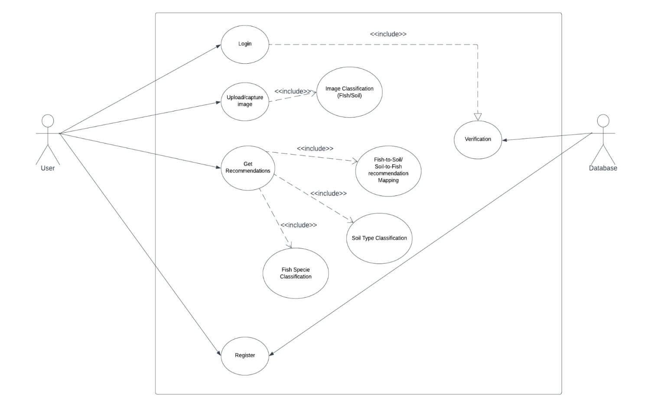

Scrapper Model



<<include>>

<<include>>



| **Use Case 1: Upload/Capture image** | | | | |
| --- | --- | --- | --- | --- |
| **Use case Id:** | | **AZ2** | | |
| **Actors:** User | | | | |
| **Features:** Image Upload/Capture, Image Classification | | | | |
| **Pre-condition:** | | 1. Application has storage and camera access privileges. | | |
| **Scenarios** | | | | |
| **Step#** | **Action** | | | **Software Reaction** |
| **1.** | User uploads image from phone storage or use the built-in camera to capture images. | | |  |
| **2.** | System performs image classification. | | | Relevant details of fish specie health are displayed. |
| **3.** |  | | |  |
| **Alternate Scenarios:** | | | | |
| **1a:** Error due to unsupported file type during upload.  **2a:** Classification error due to blurry or low quality image. | | | | |
| **Post Conditions** | | | | |
| **Step#** | **Description** | | | |
| **1.** | On successful recognition, the image is passed on to either fish species or soil type classification module. | | | |
| **2.** |  | | | |
| **Use Case Cross referenced** | | |  | |

| **Use Case 2: Image Classification (Fish/Soil)** | | | | |
| --- | --- | --- | --- | --- |
| **Use case Id:** | | **AZ3** | | |
| **Actors:** User | | | | |
| **Feature:** Image Classification | | | | |
| **Pre-condition:** | | Image is correctly captured or uploaded to the application. | | |
| **Scenarios** | | | | |
| **Step#** | **Action** | | | **Software Reaction** |
| **1.** | Image is input to the model via capture or upload | | |  |
| **2.** | Module determines image as fish image or soil image | | | Relevant image details are displayed, i.e: fish health analysis or soil details |
| **3.** |  | | |  |
| **Alternate Scenarios:** | | | | |
| **1a:** Classification error due to image not falling in defined classes. | | | | |
| **Post Conditions** | | | | |
| **Step#** | **Description** | | | |
| **1.** | Image is processed further to define a fish species or soil type it belongs to. | | | |
|  |  | | | |
| **Use Case Cross referenced** | | | Upload/Capture image, Get Recommendations | |

| **Use Case 3: Get Recommendations** | | | | |
| --- | --- | --- | --- | --- |
| **Use case Id:** | | **AZ4** | | |
| **Actors:** User | | | | |
| **Feature:** Fish Classification, Soil Classification, Fish-to-Soil and Soil-to-Fish recommendations | | | | |
| **Pre-condition:** | | Image is correctly classified as either a fish image or soil image. | | |
| **Scenarios** | | | | |
| **Step#** | **Action** | | | **Software Reaction** |
| **1.** | Image is input to fish/soil modules | | |  |
| **2.** | Module determines image class (40+ fish species and 3 soil types) | | | Classified fish specie/ soil type information is displayed. |
| **3.** | Fish specie is mapped to most suitable soil application while soil type is mapped to most suited fish species. | | | Relevant procedures are displayed along with the recommendations for both processes. |
| **Alternate Scenarios:** | | | | |
| **1a:** Classification error due to the fish specie or soil type not falling in trained classes.  **2a:** Information not being displayed to database error. | | | | |
| **Post Conditions** | | | | |
| **Step#** | **Description** | | | |
| **1.** | User can re-initiate the process by uploading or capturing new images. | | | |
|  |  | | | |
| **Use Case Cross referenced** | | | Image Classification (Fish/Soil), Upload/Capture image | |

| **Use Case 4: Fish-to-Soil/ Soil-to-Fish recommendation Mapping** | | | | |
| --- | --- | --- | --- | --- |
| **Use case Id:** | | **AZ7** | | |
| **Actors:** User | | | | |
| **Feature:** Fish-to-Soil and Soil-to-Fish recommendations | | | | |
| **Pre-condition:** | | Fish specie or Soil type are correctly identified. | | |
| **Scenarios** | | | | |
| **Step#** | **Action** | | | **Software Reaction** |
| **1.** | Image is input to the module | | |  |
| **2.** | Module performs mapping | | | Relevant feasible applications for best soil types or most suitable fish species for given soil are recommended. |
| **3.** |  | | |  |
| **Alternate Scenarios:** | | | | |
| **1a:** Information not being displayed to database error. | | | | |
| **Post Conditions** | | | | |
| **Step#** | **Description** | | | |
| **1.** | Soil type is mapped to most suitable fish species and procedures are highlighted. | | | |
|  |  | | | |
| **Use Case Cross referenced** | | | Get Recommendations | |

| **Use Case 5: Scrapper model for fish information** | | | | |
| --- | --- | --- | --- | --- |
| **Use case Id:** | | **AZ7** | | |
| **Actors:** User | | | | |
| **Feature:** Provides detailed information about all kinds of fishes after scrapping various sites on the internet | | | | |
| **Pre-condition:** | | Fish specie is correctly identified. | | |
| **Scenarios** | | | | |
| **Step#** | **Action** | | | **Software Reaction** |
| **1.** | Image is input to the module & button is pressed | | | Scrapper model is called and ran in the background which collects information from the internet. |
| **3.** |  | | |  |
| **Alternate Scenarios:** | | | | |
| **1a:** Information not being displayed to database error. | | | | |
| **Post Conditions** | | | | |
| **Step#** | **Description** | | | |
| **1.** | States of DOM should be updated | | | |
|  |  | | | |
| **Use Case Cross referenced** | | | Fish Classification | |

| **Use Case 6: LLM for nutrient extraction process automation** | | | | |
| --- | --- | --- | --- | --- |
| **Use case Id:** | | **AZ7** | | |
| **Actors:** User | | | | |
| **Feature:** Provides detailed information on how user can create the fish fertilizer with the provided resources and constraints. | | | | |
| **Pre-condition:** | | Fish specie is correctly identified. | | |
| **Scenarios** | | | | |
| **Step#** | **Action** | | | **Software Reaction** |
| **1.** | Image is input to the module & button is pressed | | | LLM model is called and ran in the background which collects information from the user and then generate a response to it, tailored to user demands. |
| **3.** |  | | |  |
| **Alternate Scenarios:** | | | | |
| **1a:** Information not being displayed to web error. | | | | |
| **Post Conditions** | | | | |
| **Step#** | **Description** | | | |
| **1.** | States of DOM (web) should be updated | | | |
|  |  | | | |
| **Use Case Cross referenced** | | | Fish Classification | |

# Functional Requirements

* *Image Upload/Capture*
  + Acquire input images from cameras in real-time or saved in phone storage.
* *Image Classification*
  + Classify image as fish image or soil image.
* *Fish Classification*
  + Classify fish species.
  + Show relevant details of the identified fish species.
* *Soil Classification*
  + Classify soil type.
  + Show relevant details of the identified soil type.
* *Fish-to-Soil and Soil-to-Fish recommendations*
  + Map the classified fish specie to the most suitable soil types with application.
  + Map the classified soil to the most suitable fish species and highlight procedures.
* *Nutrient Extraction Process Automation (Blending Instructions)*
  + Suggest the user the most optimal step-by-step, well-defined procedure on how to create the organic fertilizer given the resources as provided by the user.

# Non - Functional Requirements

*Performance Requirements*

* *Speed*:

The system must provide species recommendations within a response time of 10 seconds or less after receiving input data.

* *Precision*:

The accuracy of recommendations should be at least 90%, based on validation testing with diverse datasets.

* *Capacity*:

The system must be capable of processing a minimum of 1,000 images daily, ensuring scalability to accommodate increasing user demands.

* *Reliability*:

The system should maintain an uptime of 99.9%, minimizing downtime for maintenance or updates.

*Safety Requirements*

* *Loss Prevention*:

The system must have safeguards to prevent data loss or corruption, ensuring the integrity of both input and output data.

* *Harm Mitigation*:

The system should not recommend fish species that pose known health risks to the soil, crops, or the broader ecosystem.

* *Regulatory Compliance*:

The system must comply with relevant agricultural and environmental regulations in Pakistan, ensuring that recommendations align with established safety standards.

*Security Requirements*

* *Integrity*:

The system should ensure the integrity of recommendations and prevent tampering or manipulation of output results.

*User Documentation*

* *User Manuals*:

Comprehensive user manuals describing system functionalities, input requirements, and interpretation of results will be provided in both print and digital formats.

* *Tutorials*:

Tutorial materials, including video guides and step-by-step tutorials, will be provided to facilitate user onboarding and maximize the effective use of the system.

* *Contextual Help*:

Features will be integrated into the user interface, providing relevant assistance based on the user's interaction with the system.

# Sequence Diagram

The Sequence diagram captures the dynamic interactions within our application, illustrating the chronological flow of activities. It commences with user interactions, triggering processes like image capture through the camera, which then engage the Image Processing and AI Inference components. The sequence seamlessly integrates with the Database, querying for relevant information on soil, fish, and agricultural practices. Finally, the Recommendation System processes this data, providing user-friendly outputs and insightful guidance. This diagram serves as a visual narrative, depicting the synchronized dance of components in our innovative farming companion.

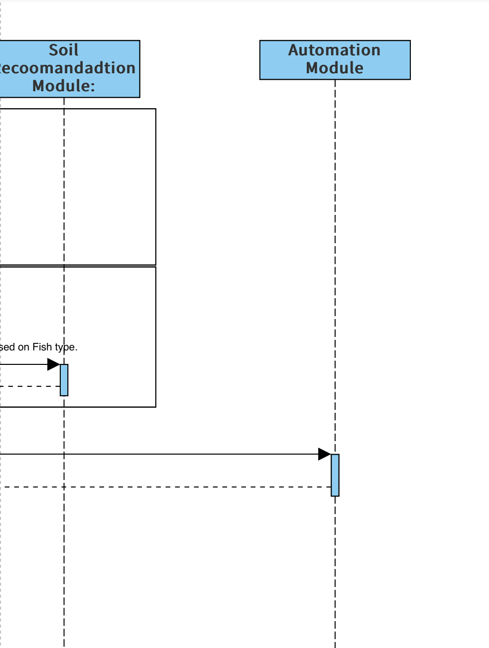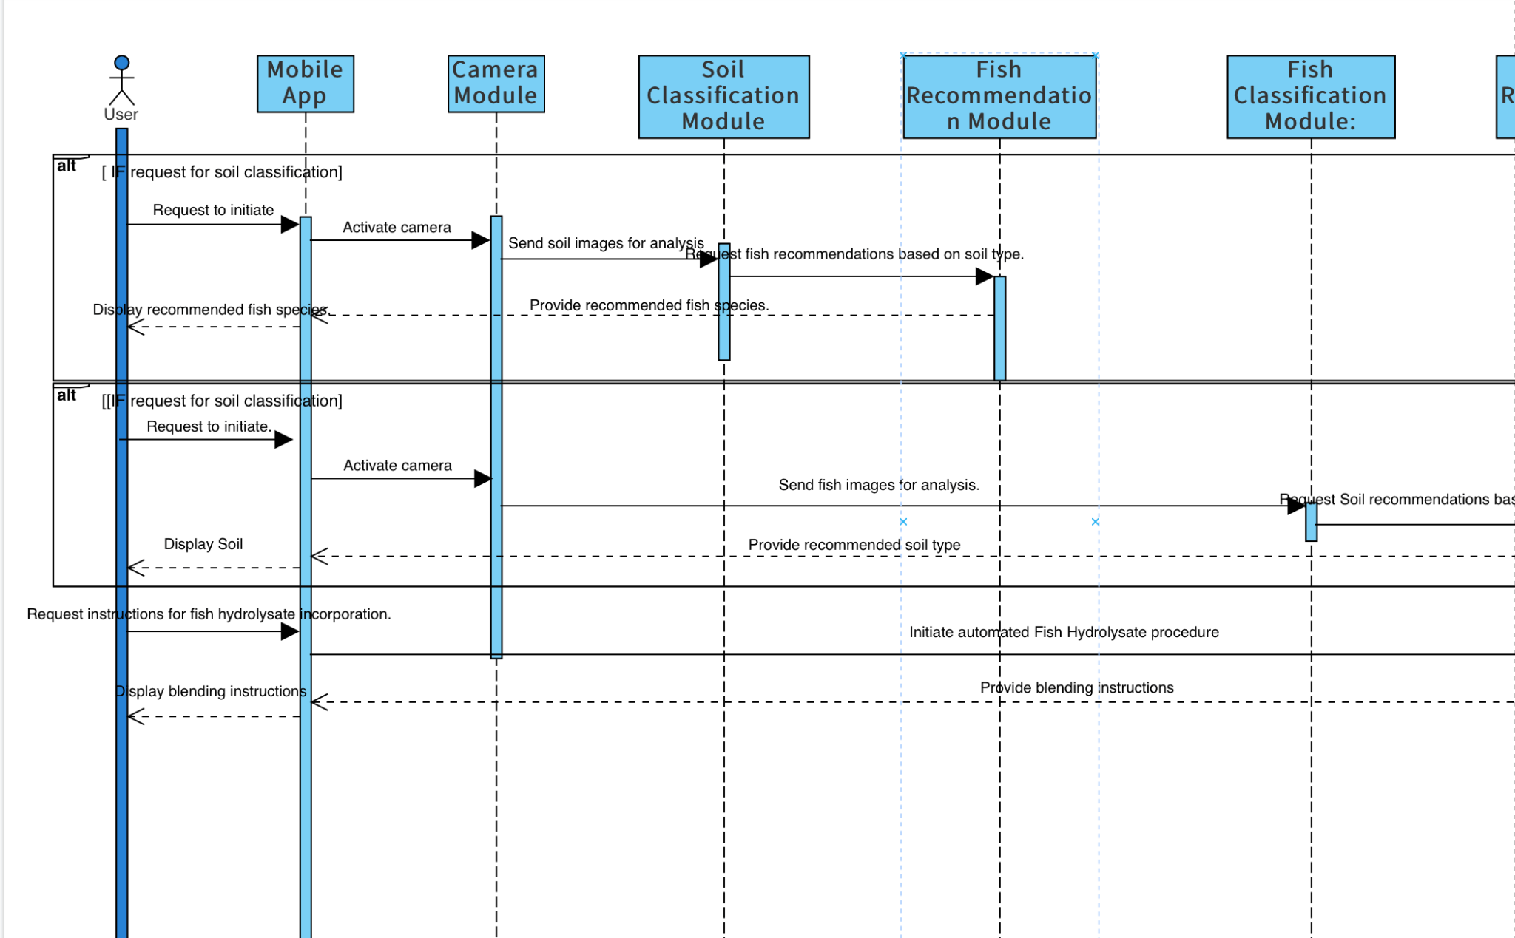

**Picture Module**

**Web app**

# Software Architecture

The Component diagram showcases the essential building blocks of our application. It outlines the core components, including Mobile Application, AI Algorithms, and Database Integration. Each component is further dissected into key sub-components, such as Soil and Fish Classification Modules and Recommendation Systems (Mapper). This visual representation offers a concise overview of the modular structure and interdependencies within our intelligent sustainable AI-driven farming application.

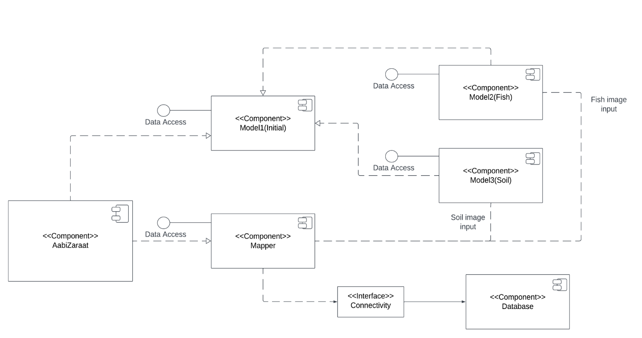



<<component>>Scrapper



<<component>>LLM



# Implementation

***Backend Code:***

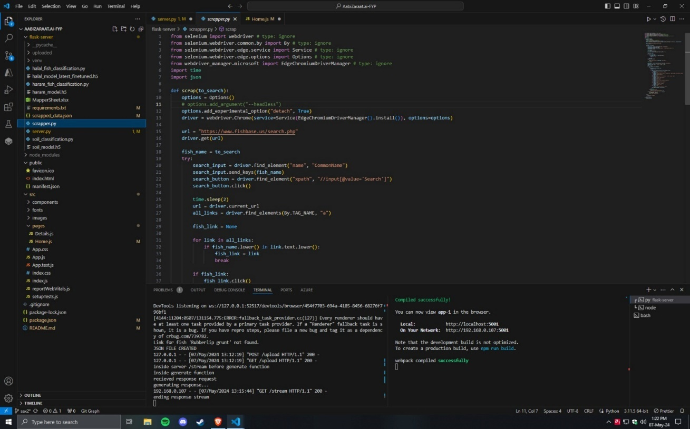

Fig 21: Scapper.py

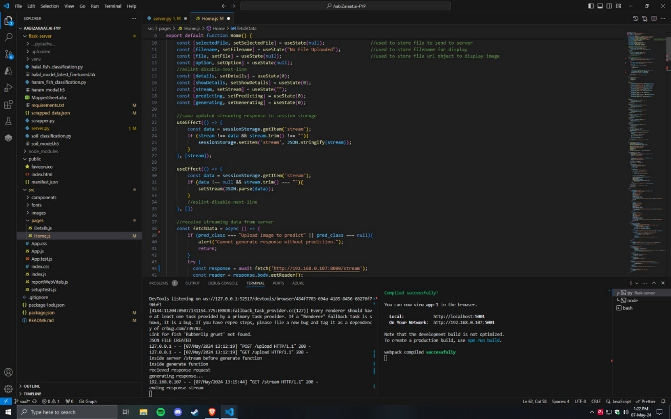

Fig 22: Home Page - Web Implementation

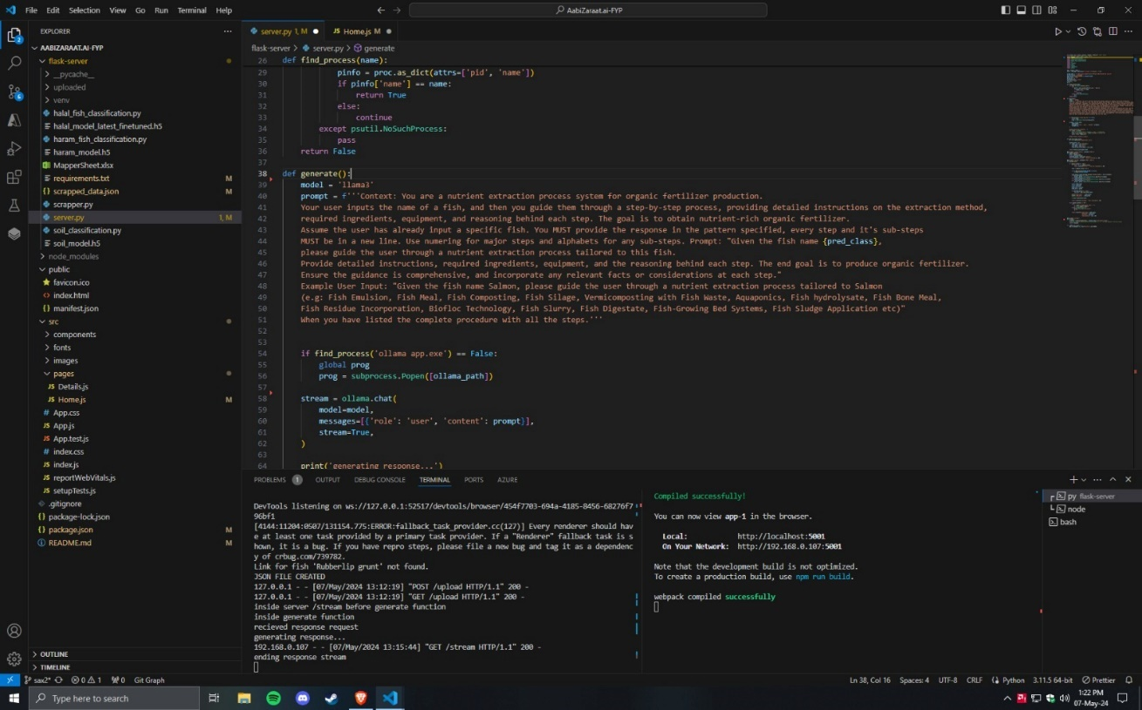

Fig 23: LLM Implementation (Server Side)

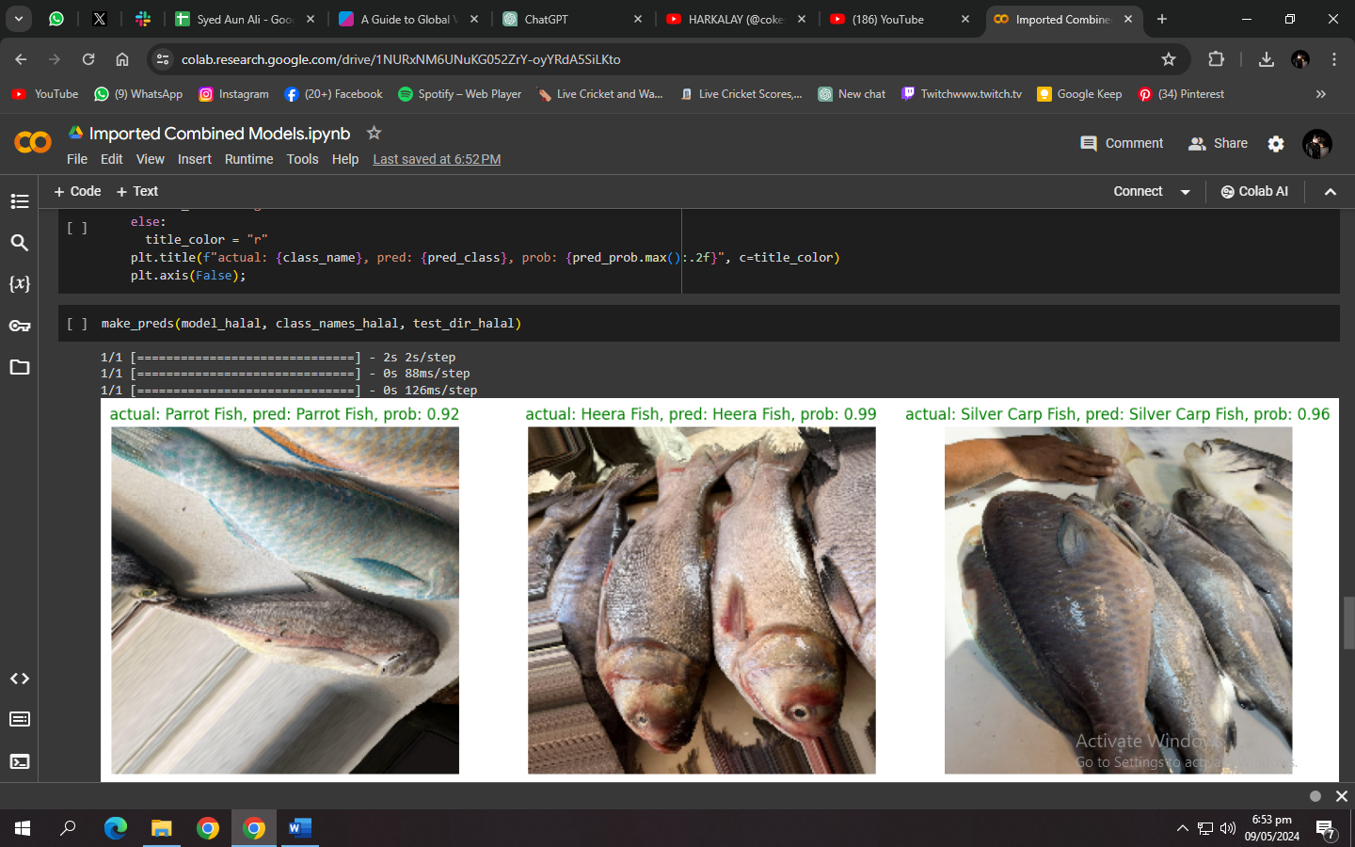

Fig 24: Halal Fish Classification Model

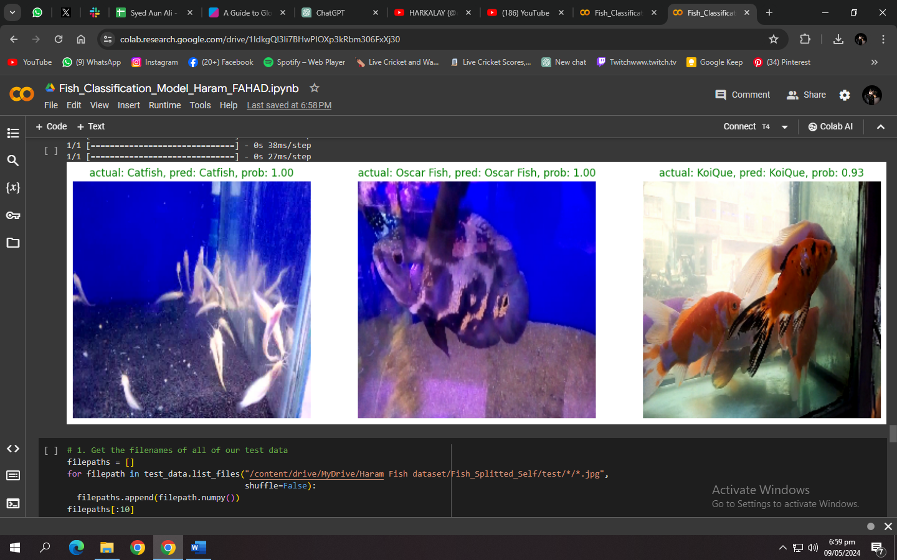

Fig 25: Haram Fish Classification Model

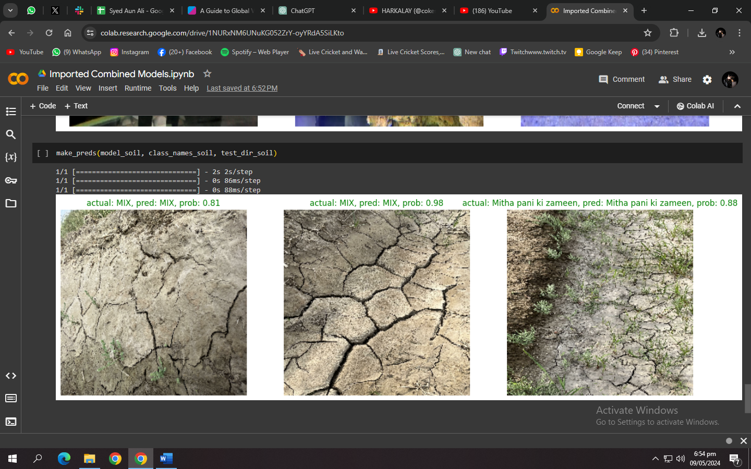

Fig 26: Soil Classification Model

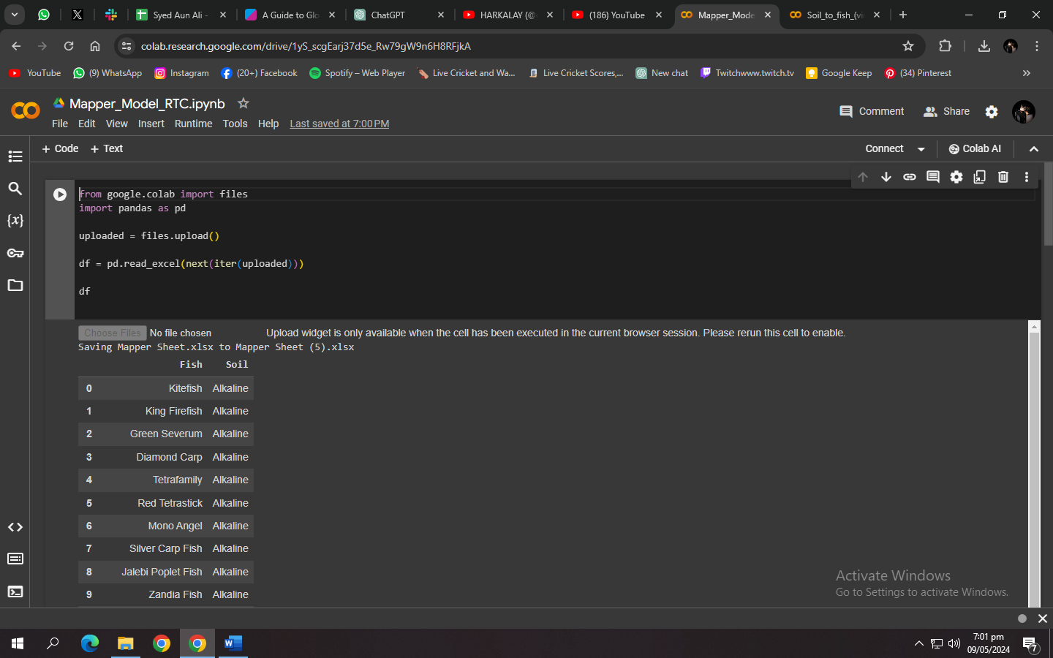

Fig 27: Mapper (Fish-to-Soil Recommender) Model

***Frontend Interface:***

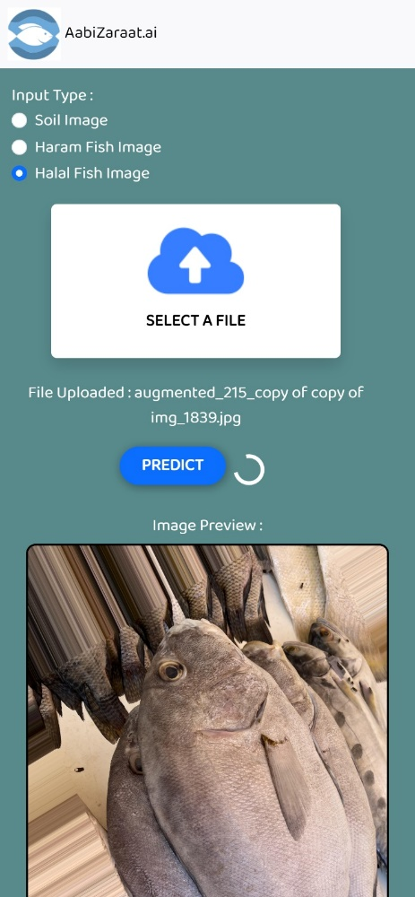

Fig 28: Classification of Fishes & Soil

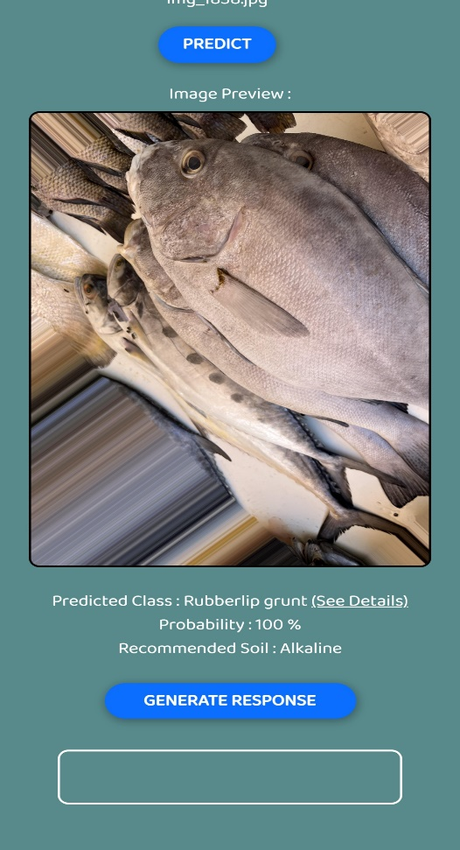

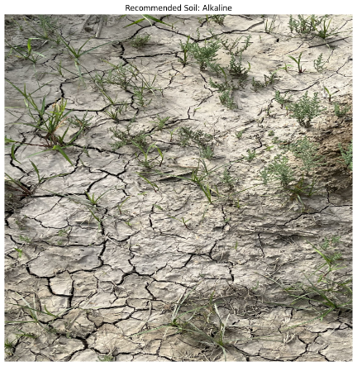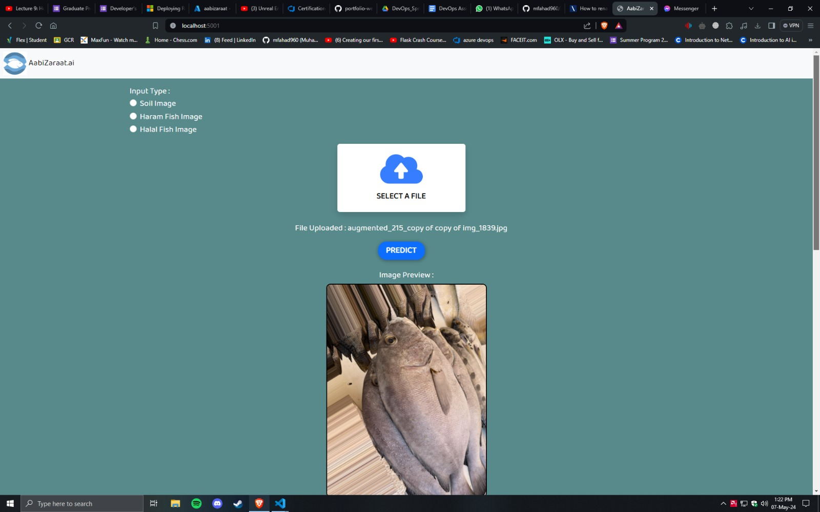

Fig 29: Compatible Soil Recommendation

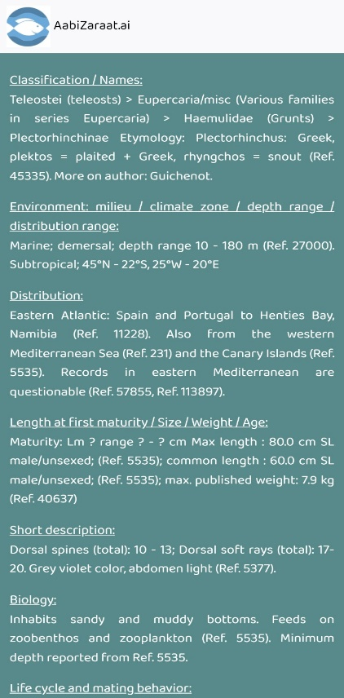

Fig 30: Fish Details (Scrapper)

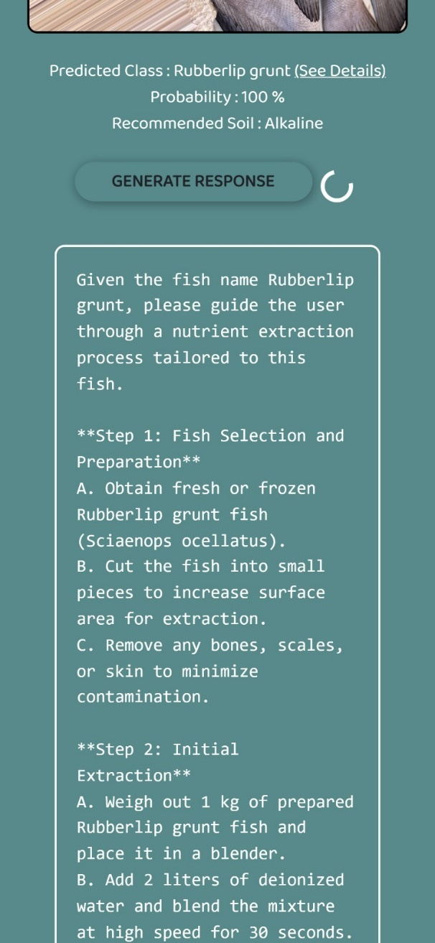

Fig 31: LLM Recommendations for automation

# Testing and Evaluation

**Testing and Evaluation**

The testing and evaluation phase of our project represents a very crucial stage in the development lifecycle, where the robustness, functionality, and efficacy of our integrated AI-driven solution for sustainable organic farming practices in Pakistan were rigorously tested and assessed. This section discusses our approach towards testing methodologies, procedures, and outcomes of our work.

**1. Functional Testing:**

Functional testing ensures quality assurance of our work, stating that every component and feature of Aabi Zaraat.ai operated seamlessly and in accordance with predefined specifications and requirements. This approach encompassed:

- *Unit Testing:* Individual modules and functions were subjected to rigorous testing in isolation. For example: all the classification computer vision models were separately tested on different datasets, and their obtained results were then plotted in a graph to showcase model’s accuracy.

- *Integration Testing:* The integration of various modules and components was thoroughly tested to verify interoperability and seamless interaction between different system elements. Firstly, individual components were created, then all of them were incorporated within a single Web App.

- *System Testing:* The system as a whole was evaluated to ascertain its overall functionality, performance, and adherence to user requirements and expectations.

**2. Performance Testing:**

Performance testing was a very important step in measuring the system's speed, scalability, and resource utilization under diverse operating conditions and workloads. This encompassed:

- *Load Testing:* The system's response time and stability were evaluated under varying levels of simulated loads to determine its robustness and its capacity to handle user requests happening at the same time. This test involved logging from many multiple users in to the system at the same time.

- *Stress Testing:* Extreme conditions were simulated in the system to assess its ability and its resilience and identify potential bottlenecks or failure points under high-stress scenarios. We stress tested our system by sending thousands of automated resource-intensive requests to the server at the same time.

- *Scalability Testing:* The system's ability to scale gracefully with increasing user demands and data volumes was evaluated. This was done in order to ensure uninterrupted service delivery and optimal performance.

**3. Compatibility Testing:**

Compatibility testing was conducted to verify our Web App, Aabi Zaraat.ai, functioned seamlessly across different devices, browsers, and operating systems, ensuring a consistent user experience regardless of the user's environment. This encompassed:

*- Browser Compatibility:* The system was tested across various web browsers, including Chrome, Firefox, Safari, and Edge, to ensure cross-browser compatibility and consistent rendering of web elements.

- *Operating System Compatibility*: Testing was performed on different operating systems, such as Windows, macOS, and Linux, to validate compatibility and functionality across diverse computing platforms.

- *Device Compatibility*: The system's performance and responsiveness were evaluated on different devices, including desktops, laptops, tablets, and smartphones, to ensure optimal user experience across form factors.

**4. Usability Testing:**

Usability testing focused on assessing the system's ease of use and user satisfaction. The aim of this was to optimize the user experience and maximize user adoption and engagement. This included:

*- User Interface (UI) Testing:* The UI design and layout were evaluated for clarity, consistency, and accessibility, with particular emphasis on user-friendly interaction patterns, like one singular page with all relevant information under respective headings.

*- Feedback Collection:* Feedback from end-users and stakeholders was actively incorporated into the design and development process, ensuring that the system's design and functionality aligned with user needs and expectations.

**5. Documentation Evaluation:**

The documentation produced throughout the project lifecycle, including LR, SRS, SDS, and the IEEE Paper, underwent rigorous evaluation to ensure accuracy, completeness, and compliance with project requirements and industry standards. This encompassed:

- *Technical Documentation Review:* The LR, SRS, SDS, and other technical documents were reviewed and validated to ensure they accurately reflected the system's design, functionality, and requirements specifications.

- *Compliance Assessment:* The documentation was assessed for compliance with relevant industry standards, best practices, and regulatory requirements, with any deficiencies addressed through revisions and updates.

- *Accessibility and Readability:* The documentation's accessibility and readability were assessed to ensure it effectively conveyed complex technical concepts and information to diverse audiences, facilitating comprehension and knowledge transfer.

**6. Performance Metrics:**

A comprehensive set of performance metrics was defined and measured to quantitatively evaluate the system's effectiveness, efficiency, and impact. These metrics included:

*- Accuracy:* The percentage of correct predictions made by the system for soil and fish (Halal & Haram) species identification, reflecting the system's precision and reliability in decision-making.

*- Speed:* The system's response time and processing speed, measured in terms of latency and throughput, reflecting its efficiency and responsiveness in handling user requests and tasks.

*- Scalability:* The system's ability to scale gracefully with increasing user demands and data volumes, assessed in terms of resource utilization, throughput, and capacity planning.

*- User Satisfaction:* Feedback from end-users and stakeholders regarding the system's usability, functionality, and overall satisfaction, providing insights into user perceptions and preferences and guiding future enhancements and improvements.

**7. Results and Analysis:**

The results of testing and evaluation were analyzed comprehensively to identify strengths, weaknesses, opportunities, and threats (SWOT) associated with the system. This analysis allowed us to get valuable insights into the system's performance, functionality, and user experience, informing decision-making regarding further development and the system’s optimization. Additionally, the findings from testing and evaluation served as a basis for iterative refinement and enhancement of the system, ensuring continuous improvement and alignment with evolving user needs and technological advancements.

In conclusion, our web app, Aabi Zaraat.ai, was a rigorously tested and a multifaceted approach was adopted which aimed at ensuring the reliability, functionality, and effectiveness of our integrated AI-driven solution for sustainable organic farming practices in Pakistan. Through systematic testing methodologies, comprehensive evaluation processes, and iterative refinement cycles, we were able to validate the system's performance, address any identified issues, and make our way for successful deployment and adoption in real-world agricultural environments.

# Conclusion

In conclusion, our research has demonstrated the significant potential of AI and computer vision in revolutionizing aquaculture and agriculture in Pakistan. The developed mobile application, designed to classify soil types and fish species, could significantly enhance farming practices and automate the fish nutrient extraction and application procedure. This innovative approach can bridge the gap between technology and farming, vital for improving the backbone of Pakistan’s economy - agriculture. This application is promising for business-to-business users, offering a comprehensive resource for efficient, intelligent, and sustainable farming practices. Moreover, the application’s scope, covering soil classification and fish assessment, can greatly optimize agricultural endeavors through its insightful recommendations and health assessments. Within merely a single tap, users can unlock a realm of agricultural insights, paving the path towards smarter, more accessible, and undoubtedly more efficient farming.

# References

[1] M. Hassaballah and K. M. Hosny (Eds.), ”Recent Advances in Computer

Vision”, DOI:10.1007/978-3-030-03000-1.

[2] A. A. Khan, A. A. Laghari, S. A. Awan, ”Machine Learning in Computer

Vision: A Review,” SIS EAI,2021, DOI: 10.4108/eai.21-4-2021.169418.

[3] Government of Pakistan, Ministry of Finance,

”Pakistan Economic Survey 2020-21,” 2021.

https://www.finance.gov.pk/survey/chapters21/02 − Agriculture.pdf.

[4] M. A. Khan and M. Ahmed, ”Review of Available Knowledge on Land

Degradation in Pakistan,” ICARDA, March 2012.

[5] ”The Impact of Fertilizers on the Environment: Inorganic vs. Organic,”

Farmerline, June 23, 2023. https://farmerline.co/

[6] Nation, ”Unsustainable farming,” The Nation, Jul. 4, 2023.

https://www.nation.com.pk/04-Jul-2023/unsustainable-farming

[7] IIPS. (2023). ”Sustainable Agriculture and Food Security: Boosting Pakistan’s Economy.” https://iips.com.pk/sustainable-agriculture-and-foodsecurity-boosting-pakistans-economy/: :text=Soil

[8] H. N. Pahalvi, L. Rafiya, S. Rashid, B. Nisar, and A. N.

Kamili, ”Chemical Fertilizers and Their Impact on Soil Health,”.

https://link.springer.com/chapter/10.1007/978-3-030-61010-41

[9] M. A. Khaskheli, ”Fertilizers and Environmental Pollution,” Agriculture Officer Sanghar.

https://www.pakissan.comfertilizers.and.environmental.pollution

[10] S. Z. H. Shah et al., ”FishPak: Fish species dataset from Pakistan for

visual features based classification,” Department of Zoology, University

of Gujrat, Pakistan; Department of Computer Science, University of

Gujrat, Pakistan; Department of Fisheries and Aquaculture, University of

Veterinary and Animal Sciences, Lahore, Pakistan; Division of Computer

Science, Mathematics and Science, Collins College of Professional

Studies, St. John’s University, New York, USA.

[11] G. Wright, ”AI is becoming an ’integral part’ of fisheries management

and seafood processing,” Mar. 20, 2023.

[12] M. M. U. Rehman, ”Advancements in Fish Farming is a Sustainable

Solution for Future Fish Demand,” Jun. 22.

[13] M. Y. Laghari, ”Aquaculture in Pakistan: Challenges and opportunities,”

Int. J. Fisheries Aquat. Stud., vol. 6, no. 2, pp. 56-59, 2018.

[14] S. Abbas, S. Fatima, and M. S. Khattak, ”The role of aquaculture

in the sustainable development of irrigated farming systems in Punjab, Pakistan,” Published online: June 28, 2008. DOI: 10.1046/j.1365-

2109.1997.00912.x.

[15] I. Ahuja et al., ”Fish and fish waste-based fertilizers in organic farming

– With status in Norway: A review,” Norwegian Centre for Organic

Agriculture (NORSØK), Tingvoll, Norway; Department of Biological

Sciences, Norwegian University of Science and Technology (NTNU),

Alesund, Norway; SINTEF Ocean, ˚ Alesund, Norway; SINTEF Ocean, ˚

Tromsø, Norway, Received May 22, 2020, Revised July 8, 2020,

Accepted July 28, 2020. DOI: 10.1016/j.wasman.2020.07.025.

[16] ”AnchoisFert: A New Organic Fertilizer from Fish Processing Waste

for Sustainable Agriculture,” Published online: March 2, 2022. DOI:

10.1002/gch2.202100141.

[17] M. Radziemska et al., ”Valorization of Fish Waste Compost as a

Fertilizer for Agricultural Use,” Original Paper, Published: April 16,

2018, vol. 10, pp. 2537-2545, 2019.

[18] M. Khan and C. A. Damalas, ”Farmers’ knowledge about common

pests and pesticide safety in conventional cotton production in Pakistan,”

Published online: July 14, 2015. DOI: 10.1016/j.cropro.2015.07.014.

[19] F. Aldosari, M. Mubushar, and M. B. Baig, ”Assessment of farmers

knowledge on pesticides and trainings on pesticide waste management

in Central Punjab – Pakistan,” Journal of Experimental Biology and

Agricultural Sciences, vol. 6, no. 1, pp. 168-175, February 2018. DOI:

10.18006/2018.6(1).168.175.

[20] M. F. Ali et al., ”Assessing Indigenous Knowledge through Farmers’

Perception and Adaptation to Climate Change in Pakistan,” Institute

of Agricultural and Resource Economics, University of Agriculture,

Faisalabad, Pakistan. Received: August 3, 2017; Accepted: February 10,

2018.

[21] S. Fahad et al., ”Farmers’ awareness level and their perceptions of

climate change: A case of Khyber Pakhtunkhwa province, Pakistan,”

Published online: 2020. DOI: 10.1016/j.landusepol.2020.104669.

[22] A. Memon, ”Agriculture: The need to increase farmers’ knowledge,”

Published: March 20, 2023